Exercise 1: Implementing the Singleton Pattern

Logger.java:

public class Logger {

private static Logger instance;

private Logger() {
System.out.println("Logger instance created.");
}

public static Logger getInstance() {
if (instance == null) {
instance = new Logger();
}
return instance;
}

public void log(String message) {
System.out.println("LOG: " + message);
}
}

SingletonTest.java:

public class SingletonTest {

public static void main(String[] args) {

Logger logger1 = Logger.getInstance();
logger1.log("First log message");

Logger logger2 = Logger.getInstance();
logger2.log("Second log message");

System.out.println("logger1 hashCode: " + logger1.hashCode());
System.out.println("logger2 hashCode: " + logger2.hashCode());

if (logger1 == logger2) {
System.out.println("Only one Logger instance exists.");
} else {
System.out.println("Multiple Logger instances exist.");
}
}
}

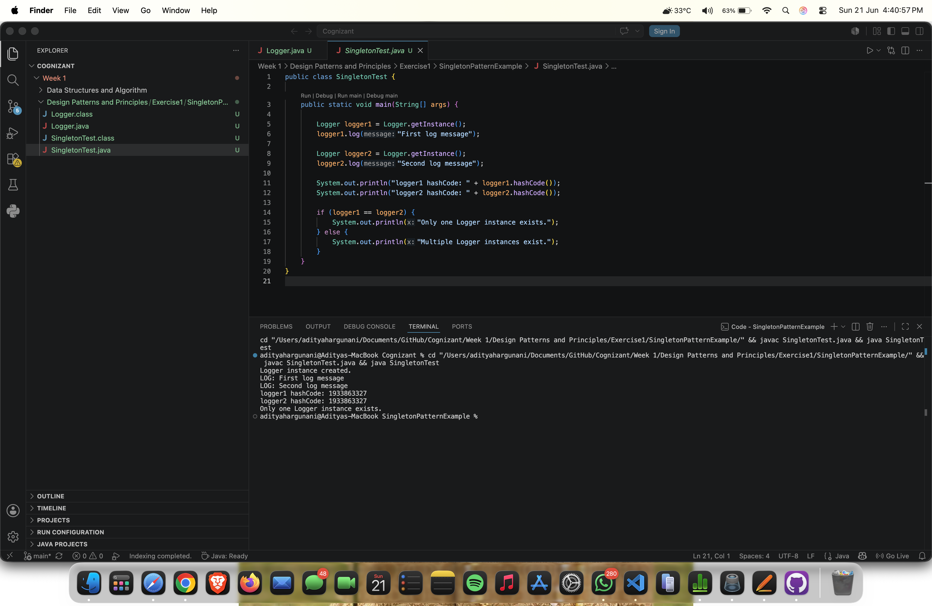
Output:

